EEE 335 Laboratory 1
Report Submission

Task 1. Schematic Design of CMOS Inverter (10 pts)
Make sure:
- Your circuit is annotated
- Your circuit schematic is legible
- Your screenshot has your name and last 3 digits of your ID are clearly written on the title bar

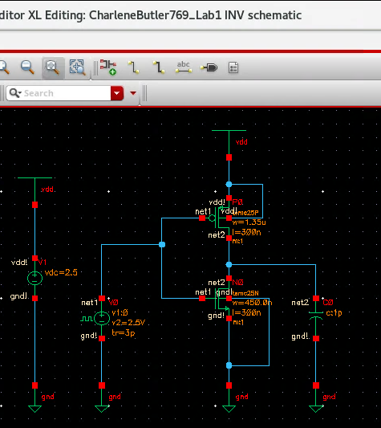Fig 1. INV Schematic

Task 2. Schematic Design of CMOS NAND (15 pts):
- 10 pts implementation
- 5 pts annotation
Make sure:
- Your circuit is annotated
- Your circuit schematic is legible
- Your screenshot has your name and last 3 digits of your ID are clearly written on the title bar

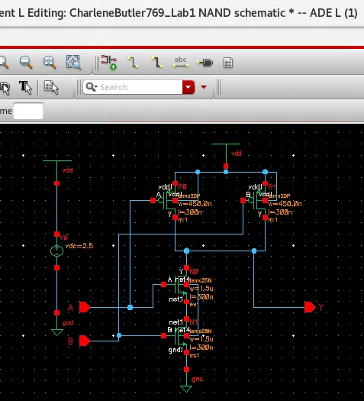Fig 2. NAND Schematic

